[Document title]



**2025**

**Human Resources Dataset Analysis**

**REPORT**

**Page 1: Overview**

**#** **The overview page in a Human Resources dataset analysis includes key metrics such as:**

* **All Employees:** The total number of employees, which is **1,470**.
* **Attrition Count:** The number of employees who have left the company, **237**.
* **Attrition Rate:** The percentage of employees who left, calculated as **16%**.
* **Active Employees:** The remaining employees who are still working in the company, which is **1,233**.
* **Average Salary:** The average salary of employees, shown as **$113K**.

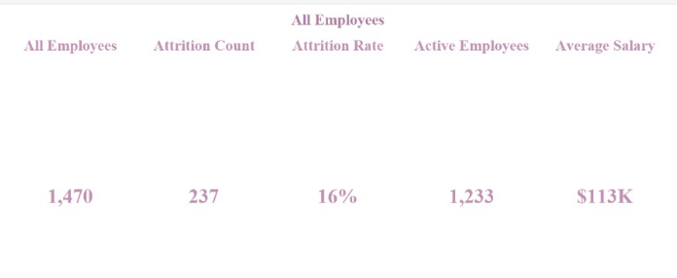

**# The distribution of employees based on gender:**

* **Female Employees:** **675** employees.
* **Male Employees:** **651** employees.
* **Other Gender:** **144** employees.

This visualization showing a relatively balanced distribution between male and female employees, with a smaller proportion identifying as "Other."

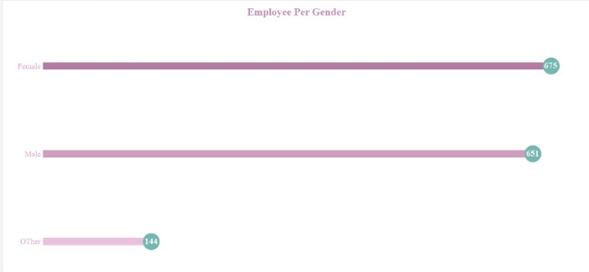

**# The distribution of employees based on Age Range:**

* **18 - 30 years:** **65%** of employees.
* **30 - 40 years:** **20%** of employees.
* **40 - 50 years:** **15%** of employees.
* **Above 50 years:** **0%** of employees.

This indicates that the majority of the workforce (65%) is young, aged between 18 and 30, while there are very few employees above 50.

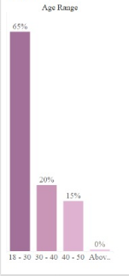

**# The distribution of employees based on Business Travel:**

* **Frequent Traveller:** **25%** of employees travel regularly.
* **Some Travel:** **15%** of employees travel occasionally.
* **No Travel:** **8%** of employees do not travel for work.

This data provides insight into workforce mobility, with a significant portion of employees traveling for work, while a smaller percentage remains stationary.

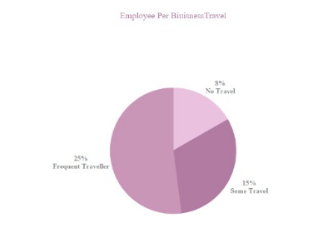

**# Table presents job satisfaction levels across different roles**:

* **Software Engineers & Data Scientists** have relatively high satisfaction levels, with around **23-24% "Very Satisfied"** employees.
* **HR roles (HR Executive, HR Business Partner, HR Manager)** have varied satisfaction levels, with **HR Business Partners showing the highest dissatisfaction (34.5%)**.
* **Sales Executives & Recruiters** have higher dissatisfaction percentages compared to technical roles.
* **Managerial roles** (such as Analytics Managers and HR Managers) show a balanced distribution of satisfaction levels.

This table provides insights into which job roles experience higher satisfaction, helping HR teams identify areas for improvement.

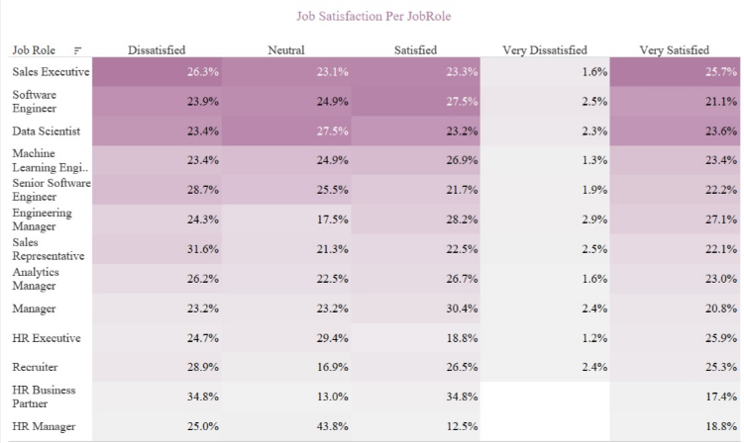

**Page 2: Employee**

**Page 3: Factors effect on Attrition**

**# Attrition based on gender and Age:**

* Young employees (18-30) have the highest attrition rates, with males leaving the most, followed by females. **39.2% Male, 35.9% Female, 7.2% Other.**
* Attrition drops significantly in the age range (30-40). Slightly more females are leaving than males.
* **Younger employees (18-30) are leaving at a much higher rate** compared to older groups.
* **Attrition decreases as employees age**, suggesting that retention improves with experience or career stability.
* **Men have higher attrition rates overall**, except for the 30-40 group where female attrition is slightly higher.

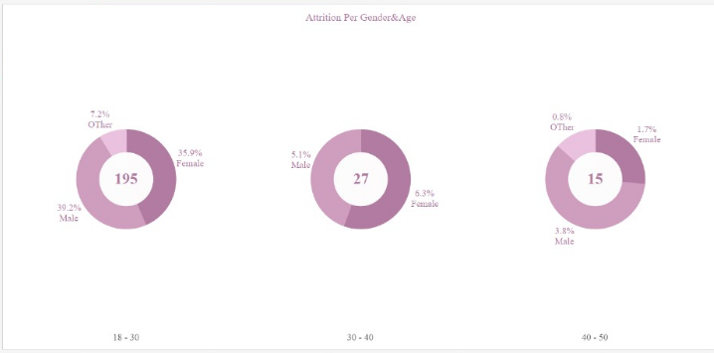

**# Attrition based on gender, Age and Salary:**

* **Attrition is highest in the 18-30 age group (195 employees leaving)**
  + This group also has the **lowest salaries (~74K on average)**.
  + Low salaries might contribute to higher attrition among younger employees.
* **Attrition drops significantly for employees aged 30-40 (27 employees leaving)**
  + Salaries in this range increase (~180K on average).
  + Higher salaries could be a factor in reducing turnover.
* **Attrition is lowest in the 40-50 age group (15 employees leaving)**
  + Salaries remain stable (~187K).
  + Employees in this group might be more stable in their careers and less likely to leave.
* **Above 50 age group has no reported attrition**
  + This group has the **highest salaries (292K on average, with males earning the most at 319K)**.
  + High salaries and senior positions contribute to job retention.

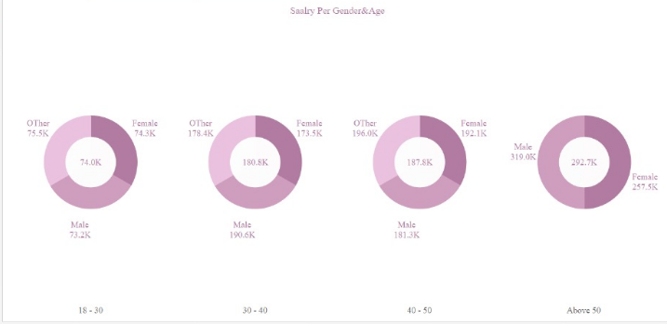

**# OverTime (yes) based on gender, Age:**

* **Total employees working overtime: 285 for Ages 18 – 30, with (32.9%) for Males.** 
  + Younger employees are more likely to work overtime, possibly due to career growth motivation or lower responsibilities outside of work.
* Overtime decreases significantly in the age group from **30 - 40**, potentially due to work-life balance priorities.
* Overtime continues to decline as employees grow older,the total employees working overtime equal 48 for Ages 40 – 50.
* **For Age Above 50, overtime is almost non-existent (0.2%) and only among females.**
  + Senior employees, likely in high-level positions, may have better work-life balance and less need for overtime.

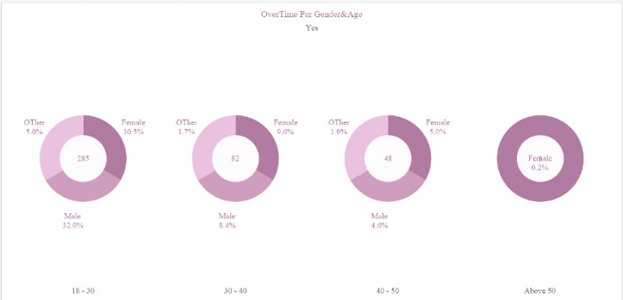

**# Attrition rate based on gender, Salary and overtime (yes):**

* **Males experience the highest attrition despite similar salaries.**
* This could indicate job dissatisfaction or higher career-switching tendencies.
* **Overtime appears to be a factor in attrition.**
* Employees with excessive overtime may experience burnout, leading to higher attrition.
* **Low salaries** might contribute to higher attrition as shown above.

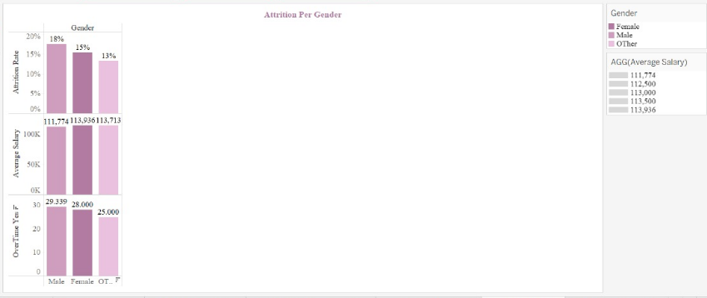

**# Attrition rate based on Age, Salary and overtime (yes):**

* **Attrition is highest among younger employees.**
* They may leave due to low salaries, career shifts, or job dissatisfaction.
* **Higher salaries contribute to lower attrition.**
* Employees aged 50+ with the highest salaries have **zero attrition.**
* **Overtime might be a contributing factor to attrition.**
* Younger employees work more overtime, which may lead to **burnout and higher turnover.**

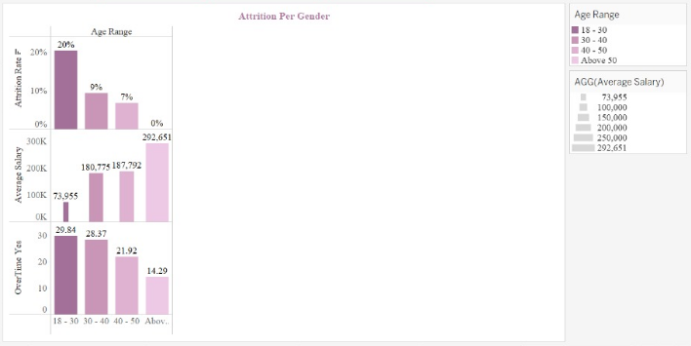

**#** Attrition based on **Marital** status and **Salary**:

* Single employees have the highest attrition rate (23%).
* Single employees are more likely to leave the company compared to married and divorced employees. This could be due to job mobility, fewer family responsibilities, or career changes.
* Single employees earn the lowest average salary ($104,302) compare to ($117,478) for Married and ($119,453) for Divorced.
* Higher salaries for married and divorced employees may provide **financial stability**, leading to lower attrition rates.

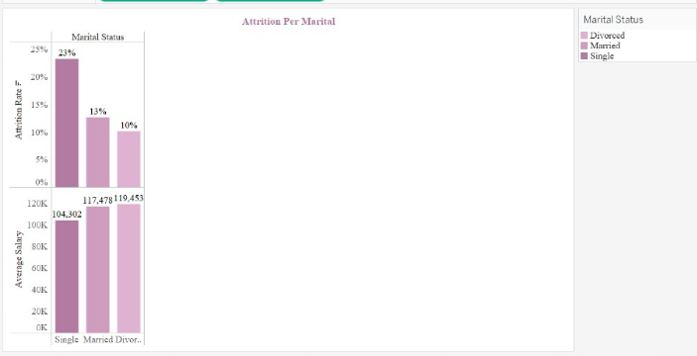

**# Attrition based on Distance from work and Overtime(yes):**

* Employees living more than 40 km from work have the highest attrition rate (20%). Might experience **travel fatigue**, leading to a higher attrition rate.
* Moderate commuting distances **(10-40 km) show the lowest attrition rates.** A balanced commute may offer better work-life balance, reducing turnover.
* Employees living 1-10 km work the most overtime (32,787 hours).
* Employees closer to work tend to work more overtime, which might contribute to higher stress and turnover.

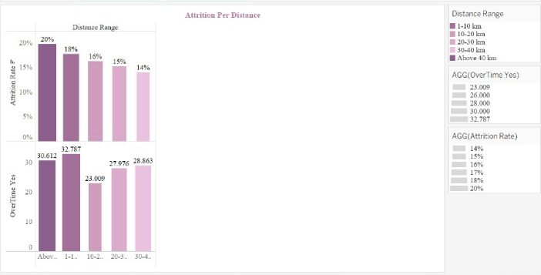

**# Attrition based on Business Travel:**

* Frequent Travelers Have the Highest Attrition Rate **(25%)** Possible reasons:
  + Burnout from frequent travel.
  + Work-life balance issues due to constant travel.
  + Increased stress and job dissatisfaction.
* Employees with Some Travel Have a Moderate Attrition Rate **(15%)** Possible reasons:
  + Some travel might be manageable.
  + Employees may still have work-life balance.
* Employees with No Travel Have the Lowest Attrition Rate **(8%)** Possible reasons:
  + Stability in **routine and work environment**.
  + Less stress from travel.
  + Better **work-life balance**.
* **Recommendations:**
* Provide **better travel policies** (e.g., flexible schedules, additional benefits for frequent travelers).
* Offer **remote work options** for employees who travel a lot.
* Monitor **employee satisfaction and stress levels** related to business travel.

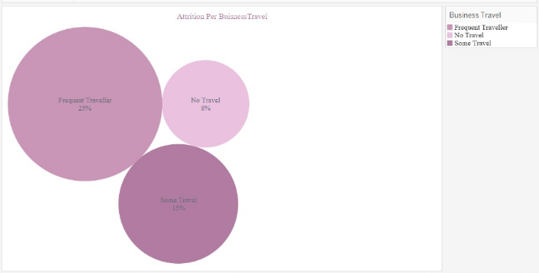

**# Attrition based on Education Level:**

* Employees with **No Formal Qualifications** have the **highest attrition rate (18%)**.
* High school graduates also have a **relatively high attrition rate (16%)**.
* Bachelor’s and Master’s Degree Holders Show Moderate Attrition Rates.
* Doctorate Holders Have the **Lowest Attrition (10%) Possible reasons:**
* Higher job stability and satisfaction.
* Access to higher salaries and leadership roles.
* Greater specialization makes them less likely to switch jobs.
* Employees with **higher education levels** earn more, **Doctorate earn** $154,269 compared to $94,983 for **No Formal Qualifications.**
* The **salary gap** explains **lower attrition among highly educated employees**, as they have better-paying jobs.
* Employees with **higher education levels tend to work fewer overtime hours**:
* **Doctorate Degree:** **29.16 hours**
* Higher-educated employees often work in senior positions that require less overtime.
* Employees with lower education levels might work in overtime-heavy roles

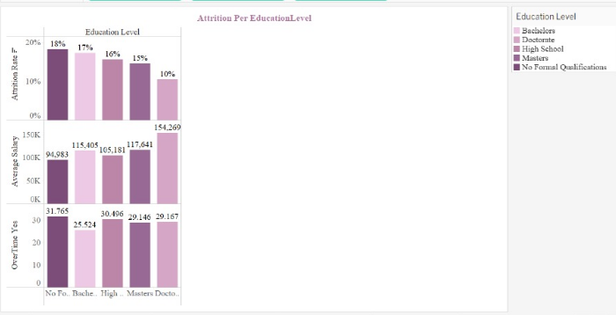

**# Attrition based on Job Role:**

* **Sales Representative (40%)** and Recruiter (38%) **→ Highest attrition,** Possible reasons:
* High-pressure jobs with aggressive targets.
* Commission-based earnings create income instability.
* Frequent rejections lead to job dissatisfaction.
* Data Scientist (24%) and Software Engineer (16%) **→** Moderate Attrition, Possible reasons:
* Software Engineers might leave for better tech stacks or remote work flexibility.
* HR Executives may experience burnout due to handling employee relations & conflicts.
* Engineering Manager (3%) and HR Manager & HR Business Partner (0%) → Most stable roles, Possible reasons:
* leadership roles (HR, Managers, Engineering, Analytics) provide stability.
* Specialized skills (ML, Senior Software) make switching jobs less frequent.
* Higher salaries & career growth opportunities keep employees engaged.

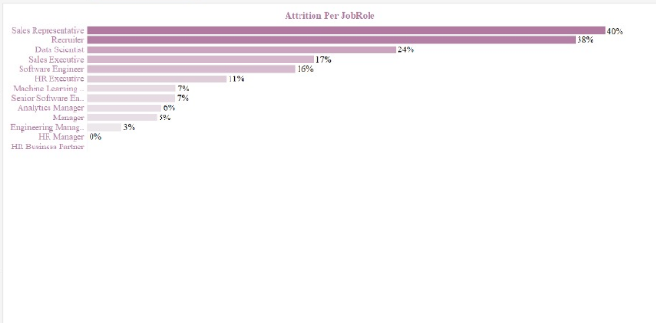

**# Salary based on Job Role:**

* Recruiter ($37.6K) and Sales Representative ($40.7K) → lowest Salary
* Recruiters & Sales Representatives earn the least, despite having high attrition rates (38% & 40%).
* Low salaries in high-pressure jobs could be a major reason for turnover.
* Data Scientist ($56.1K) and Software Engineer ($52.0K) → Moderate Salary
* Software Engineers & Data Scientists earn relatively low compared to specialized roles, which may explain moderate attrition (16% & 24%).
* Engineering Manager ($256.3K), HR Business Partner ($314.0K), Analytics Manager ($346.5K) and HR Manager (449.3K) → HighestSalary
* HR Managers earn the most ($449.3K), despite 0% attrition!
* Managers & Engineering Managers receive significantly higher salaries than technical roles.
* HR Business Partners & Analytics Managers are among the highest-paid professionals, likely due to their strategic impact on the business.

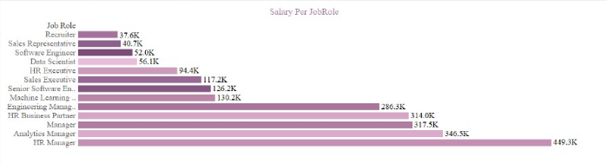

**# OverTime based on Job Role:**

* HR Business Partner (42.86 h), Software Engineer (33.33 h) and Analytics Manager (33.08 h) →The Most Overtime
* HR Business Partners work the most overtime (42.86h), suggesting high job demands & responsibilities.
* Software Engineers (33.33h) frequently work beyond normal hours, possibly due to tight deadlines & workload pressure.
* Analytics Managers (33.08) also have significant overtime, which may be driven by data-heavy projects & decision-making support.
* Recruiter (29.17h), Sales Executive (29.05h) and Sales Representative (28.0h) →The Mid-Tier Overtime.
* Recruiters & Sales professionals put in extra hours, likely due to quotas, hiring targets & client interactions.
* HR Executive (21.43h), Data Scientist (24.14h) and HR Manager (25h) →The least Overtime.
* **HR Managers (25h) work less overtime compared to HR Business Partners (42.86h), highlighting different role expectations.**

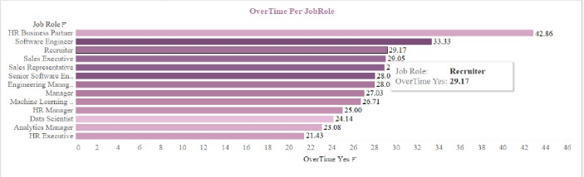

**# Attrition based on Overtime and Ethnicity.**

* Native American or Alaskan (23%) and Mixed Ethnicities (22%) → Highest Attrition Rates
* These groups have the highest attrition rates, indicating possible workplace challenges, lower job satisfaction, or career growth limitations.
* Native American also have the most overtime work (35h)
* High overtime levels can contribute to burnout & attrition, especially for Native American employees who already have the highest attrition rate (23%).
* Balancing workload, offering flexible work policies, and wellness programs can help reduce stress and improve retention.

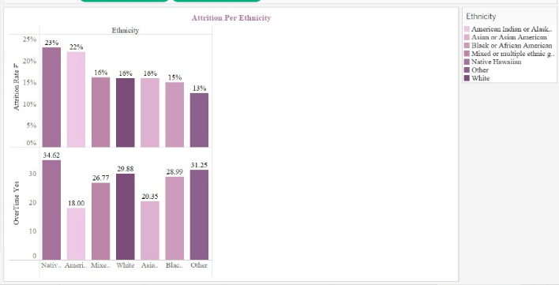

**# Attrition per years with current Manager.**

* Highest Attrition in the First Year, Employees with less than 1 year under their current manager have the highest attrition rate at 27%. **Possible Causes:**
* Poor manager-employee relationships.
* Employees may leave quickly if they feel unappreciated or overwhelmed.
* Attrition Declines but Remains Noticeable in Years 1-3 from (17- 9%). **Possible Causes:**
* Employees might be evaluating long-term career growth opportunities and deciding to stay or leave based on job satisfaction.
* Lowest Attrition in Long-Term Managerial Relationships, employees who have been with their manager for 8+ years have 0% attrition. **Possible Causes:**
* This suggests that strong, long-term manager relationships lead to stability and retention.

